**Creating Microservices for account and loan**

Account Microservice

account.xml

<?xml version="1.0" encoding="UTF-8"?>

<beans xmlns="http://www.springframework.org/schema/beans"

xmlns:util="http://www.springframework.org/schema/util"

xmlns:xsi="http://www.w3.org/2001/XMLSchema-instance"

xsi:schemaLocation="

http://www.springframework.org/schema/beans

http://www.springframework.org/schema/beans/spring-beans.xsd

http://www.springframework.org/schema/util

http://www.springframework.org/schema/util/spring-util.xsd">

<!-- Employee List -->

<util:list id="accountList">

<bean class="com.cognizant.account.Account">

<property name="number" value="00987987973432"/>

<property name="type" value="savings"/>

<property name="balance" value="234343"/>

</bean>

</util:list>

</beans>

AccountController.java

package com.cognizant.account;

import org.springframework.beans.factory.annotation.Autowired;

import org.springframework.web.bind.annotation.*;

*@RestController*

*@RequestMapping*("/accounts")

*@CrossOrigin*

public class AccountController {

*@Autowired*

public final AccountService accountService;

public AccountController() {

accountService = new AccountService();

}

*@GetMapping*("/{number}")

public Account getEmployeeById(*@PathVariable* String number) {

return accountService.getAccount(number);

}

}

AccountService.java

package com.cognizant.account;

import java.util.ArrayList;

import java.util.List;

import org.springframework.context.ApplicationContext;

import org.springframework.context.support.ClassPathXmlApplicationContext;

import org.springframework.stereotype.Service;

*@Service*

public class AccountService {

private static ArrayList<Account> *ACCOUNT_LIST*;

public AccountService() {

try {

ApplicationContext context = new ClassPathXmlApplicationContext("account.xml");

List<Account> accounts = (List<Account>) context.getBean("accountList");

*ACCOUNT_LIST* = new ArrayList<>(accounts);

} catch (Exception e) {

e.printStackTrace();

throw e; // rethrow to see the cause in logs

}

}

Account getAccount(String number) {

return *ACCOUNT_LIST*.stream()

.filter(e -> e.getNumber() == number)

.findFirst()

.orElseThrow(() -> new RuntimeException("Account not found"));

}

}

Account.java

package com.cognizant.account;

import lombok.Data;

*@Data*

public class Account {

String number;

String type;

int balance;

}

AccountApplication.java

package com.cognizant.account;

import org.springframework.boot.SpringApplication;

import org.springframework.boot.autoconfigure.SpringBootApplication;

*@SpringBootApplication*

public class AccountApplication {

public static void main(String[] args) {

SpringApplication.*run*(AccountApplication.class, args);

}

}

Output

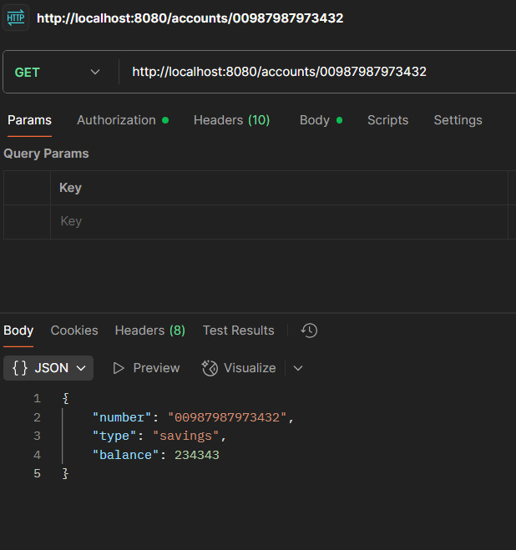

Loan Microservice

application.properties

spring.application.name=loan

server.port=8081

LoanController.java

package com.cognizant.loan;

import org.springframework.beans.factory.annotation.Autowired;

import org.springframework.web.bind.annotation.*;

*@RestController*

*@RequestMapping*("/loan")

*@CrossOrigin*

public class LoanController {

*@Autowired*

public final LoanService loanService;

public LoanController() {

loanService = new LoanService();

}

*@GetMapping*("/{number}")

public Loan getEmployeeById(*@PathVariable* String number) {

return loanService.getLoan(number);

}

}

LoanService.java

package com.cognizant.loan;

import java.util.ArrayList;

import java.util.List;

import org.springframework.context.ApplicationContext;

import org.springframework.context.support.ClassPathXmlApplicationContext;

import org.springframework.stereotype.Service;

*@Service*

public class LoanService {

private static ArrayList<Loan> *LOAN_LIST*;

public LoanService() {

try {

ApplicationContext context = new ClassPathXmlApplicationContext("loan.xml");

List<Loan> loans = (List<Loan>) context.getBean("loanList");

*LOAN_LIST* = new ArrayList<>(loans);

} catch (Exception e) {

e.printStackTrace();

throw e; // rethrow to see the cause in logs

}

}

public Loan getLoan(String number) {

return *LOAN_LIST*.stream()

.filter(e -> e.getNumber() == number)

.findFirst()

.orElseThrow(() -> new RuntimeException("Loan not found"));

}

}

Loan.java

package com.cognizant.loan;

import lombok.Data;

*@Data*

public class Loan {

String number;

String type;

int loan;

int emi;

int tenure;

}

loan.xml

<?xml version="1.0" encoding="UTF-8"?>

<beans xmlns="http://www.springframework.org/schema/beans"

xmlns:util="http://www.springframework.org/schema/util"

xmlns:xsi="http://www.w3.org/2001/XMLSchema-instance"

xsi:schemaLocation="

http://www.springframework.org/schema/beans

http://www.springframework.org/schema/beans/spring-beans.xsd

http://www.springframework.org/schema/util

http://www.springframework.org/schema/util/spring-util.xsd">

<!-- Employee List -->

<util:list id="loanList">

<bean class="com.cognizant.loan.Loan">

<property name="number" value="H00987987972342"/>

<property name="type" value="car"/>

<property name="loan" value="400000"/>

<property name="emi" value="3258"/>

<property name="tenure" value="18"/>

</bean>

</util:list>

</beans>

LoanApplication.java

package com.cognizant.loan;

import org.springframework.boot.SpringApplication;

import org.springframework.boot.autoconfigure.SpringBootApplication;

*@SpringBootApplication*

public class LoanApplication {

public static void main(String[] args) {

SpringApplication.*run*(LoanApplication.class, args);

}

}

Output

